Yelp: <https://www.yelp.com/biz/tian-fu-noodle-corvallis>

About: This is a Chinese (Sichuanese) noddle shop in the Corvallis which nearby OSU. This restaurant serves authentic Chinese (Sichuanese) noodles and dumplings. The chef’s special is Tian Fu noodle and Beef stew with gluten-free noodle.

Beef stew noodle(spicy) – $9.5

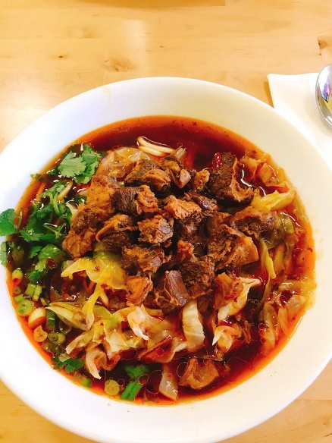

Beef stew with gluten-free noodle(spicy) - $10.0

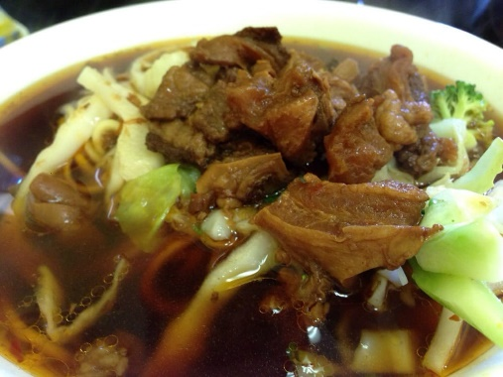

Braised Pork noodle soup - $9.0

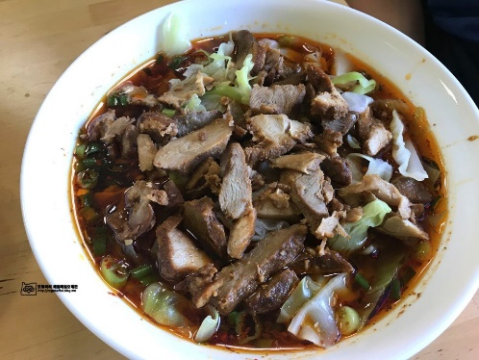

Braised Pork gluten-free noodle soup - $10.0

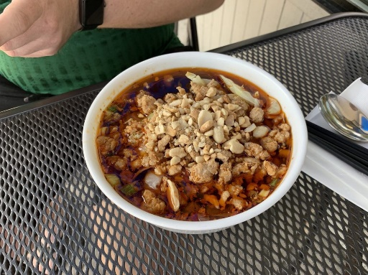

Dan Dan noodle(spicy) - $8.5

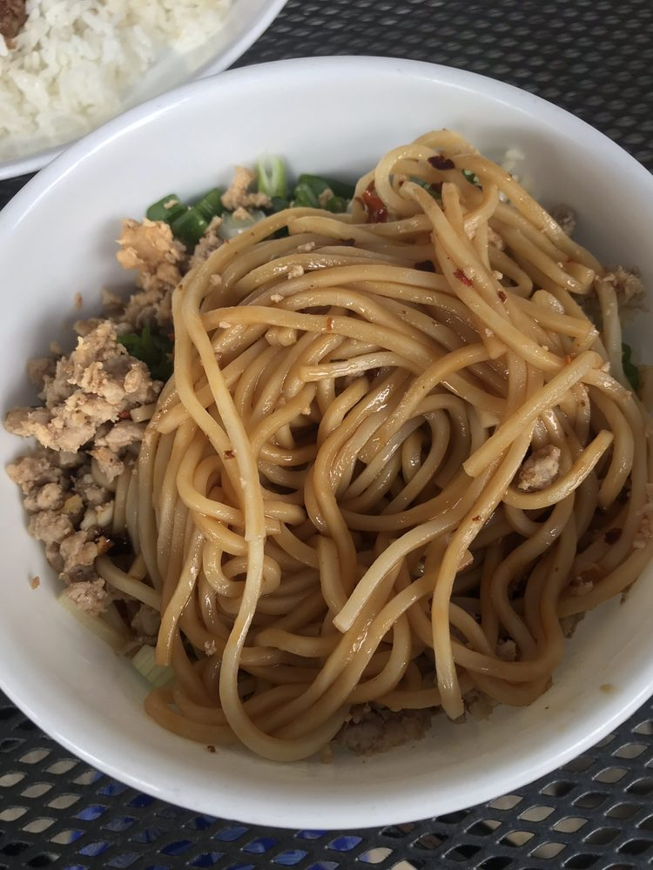

Shiitake mushroom chicken noodle soup - $8.5

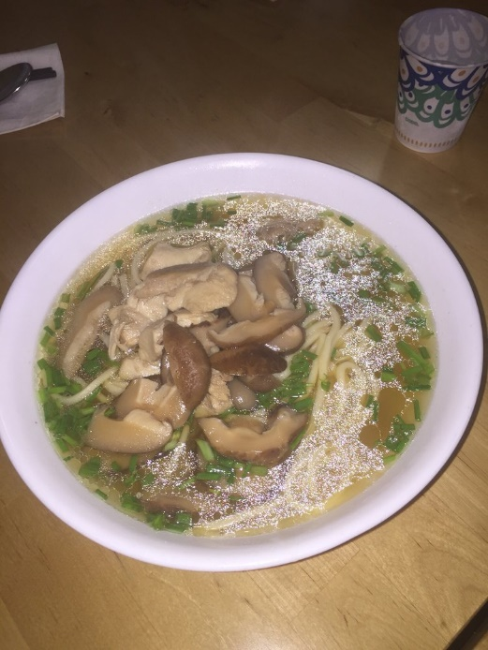

Shiitake mushroom chicken gluten-free noodle - $9.5

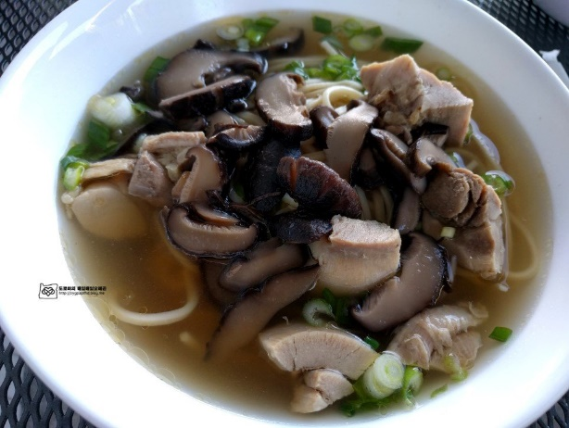

Cold noodle with chicken(spicy) – $8.5

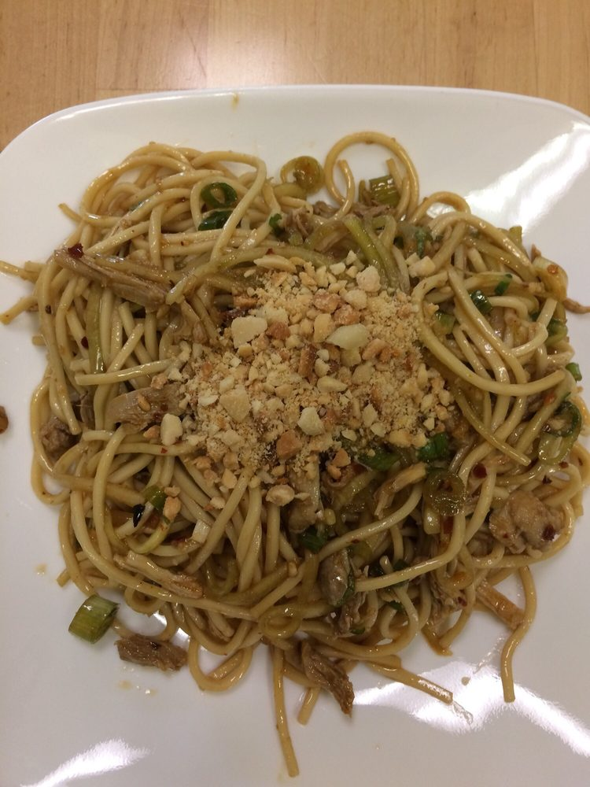

Tian Fu noodle(spicy) - $9.0

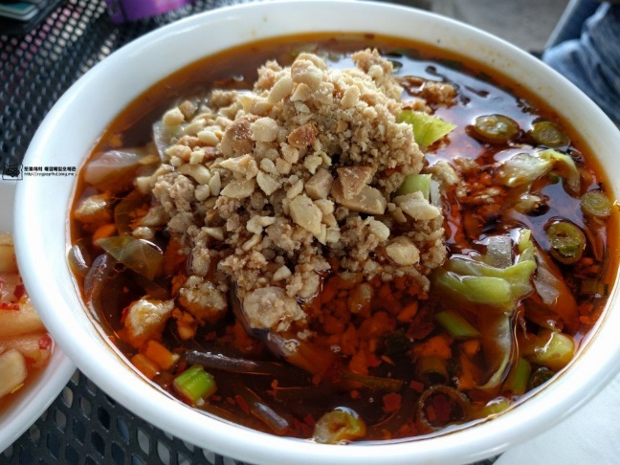

Hand-Made Dumpling - $9.5

